Conditional Access Policy Configuration:
  - Lab Scenario: Set up a Conditional Access policy that requires multifactor authentication (MFA) for all users when they are accessing a sensitive application from outside the corporate network.
  - Skills Demonstrated: You can enforce Zero Trust principles and secure access based on user, location, device, and application context.

Prerequisites
- Administrative Rights: You must have Global Administrator or Security Administrator privileges (which you confirmed you have).
- Microsoft Entra ID P1/P2 License: Conditional Access requires at least a P1 license (P2 is included with E5).
- Test Users: Create at least two test user accounts.
- Test Application: Identify or create a non-critical "sensitive application" (e.g., a Microsoft 365 app like SharePoint Online or a registered Enterprise Application).
- MFA Setup: Ensure your test user accounts are already registered for Multifactor Authentication (MFA).

Prerequisite 1 & 3: Create Test Users and Set Up MFA
Create the Test User Accounts
- Go to the Microsoft Entra admin center.
- In the left navigation menu, navigate to Users > All users.
- Click + New user > Create new user.
- Create two separate user accounts with these details (use your own domain):
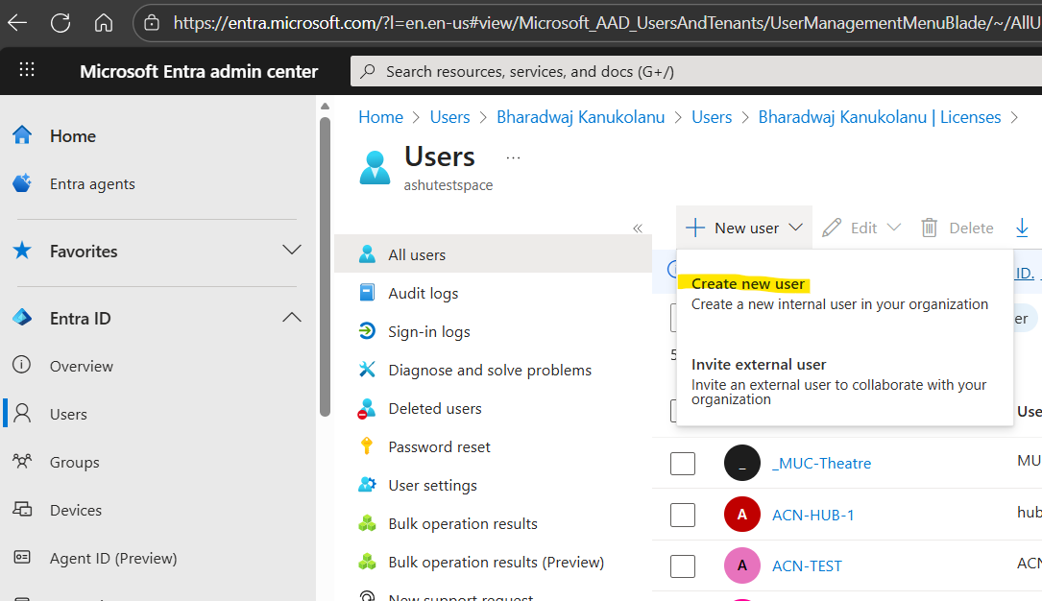
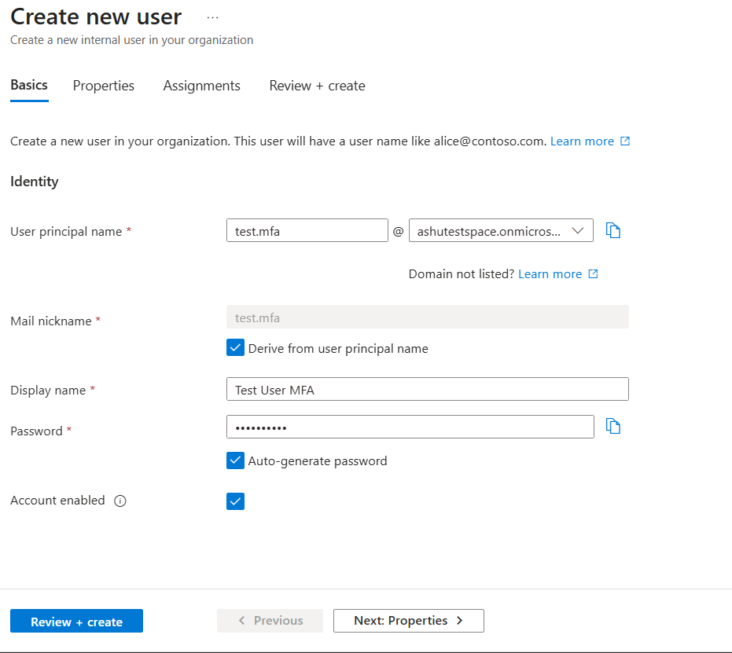
Click on review + create button

User 1 (Test Success):
    - User principal name: test.mfa@yourdomain.com
    - Display name: Test User MFA
Display name: Test User MFA
User Principal name: test.mfa@ashutestspace.onmicrosoft.com
Password: Luca307610
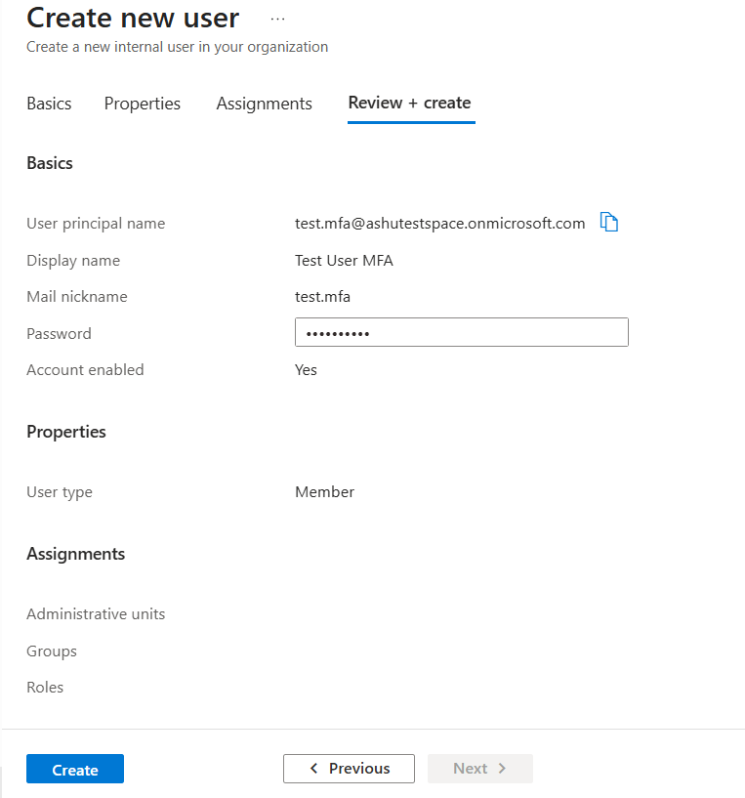

When clicked on create button, new user should appear in All users list.
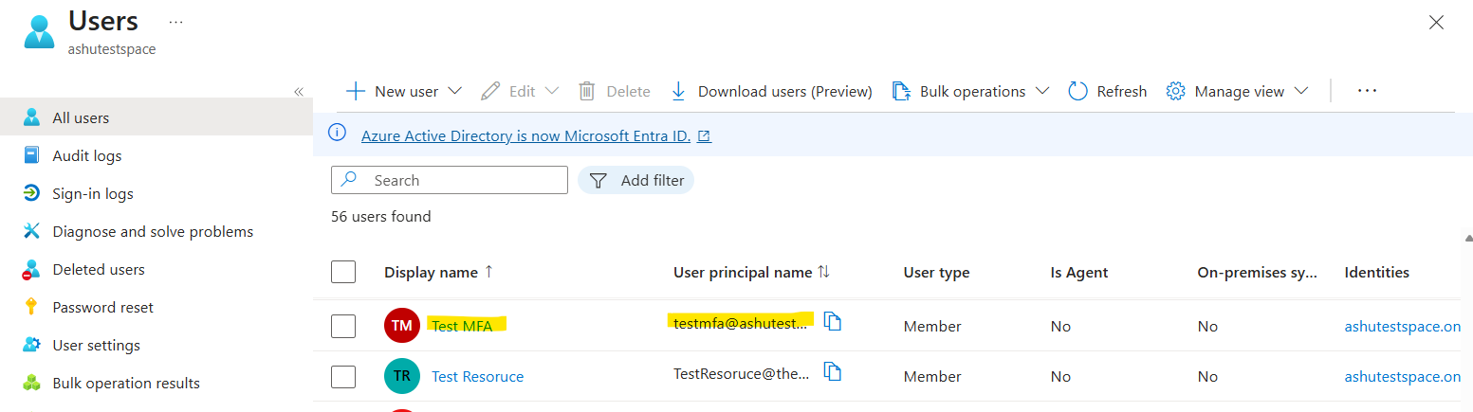

User 2 (Test Failure):
    - User principal name: test.nomfa@yourdomain.com
    - Display name: Test User No MFA (We'll use this one to show a successful block if we didn't set up MFA, but ideally, we should set up MFA for both to test the prompting.)
Display name: Test User No MFA
User Principal name: test.nomfa@ashutestspace.onmicrosoft.com
Password: Yuwa111331

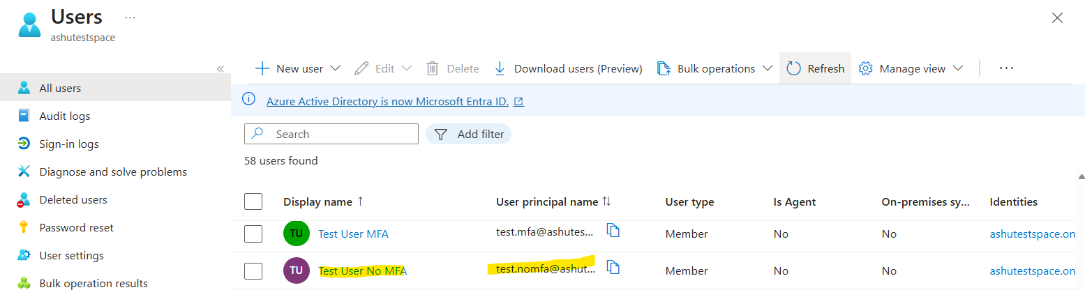
- Assign a temporary password and ensure you check the box for Require user to change password on first sign-in.

Setup MFA
Force Test Users to Register for MFA
To satisfy the prerequisite that MFA is set up, you need to trigger the registration process for the test accounts.
- As an administrator, go to Protection > Identity Protection.
- In the left menu, select MFA registration policy.
- Set the policy status to On.
- Under Users, select Select individuals and groups and add your two test users (Test User MFA and Test User No MFA).
- Click Save.
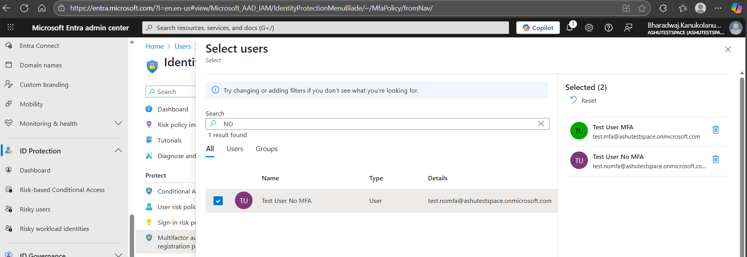
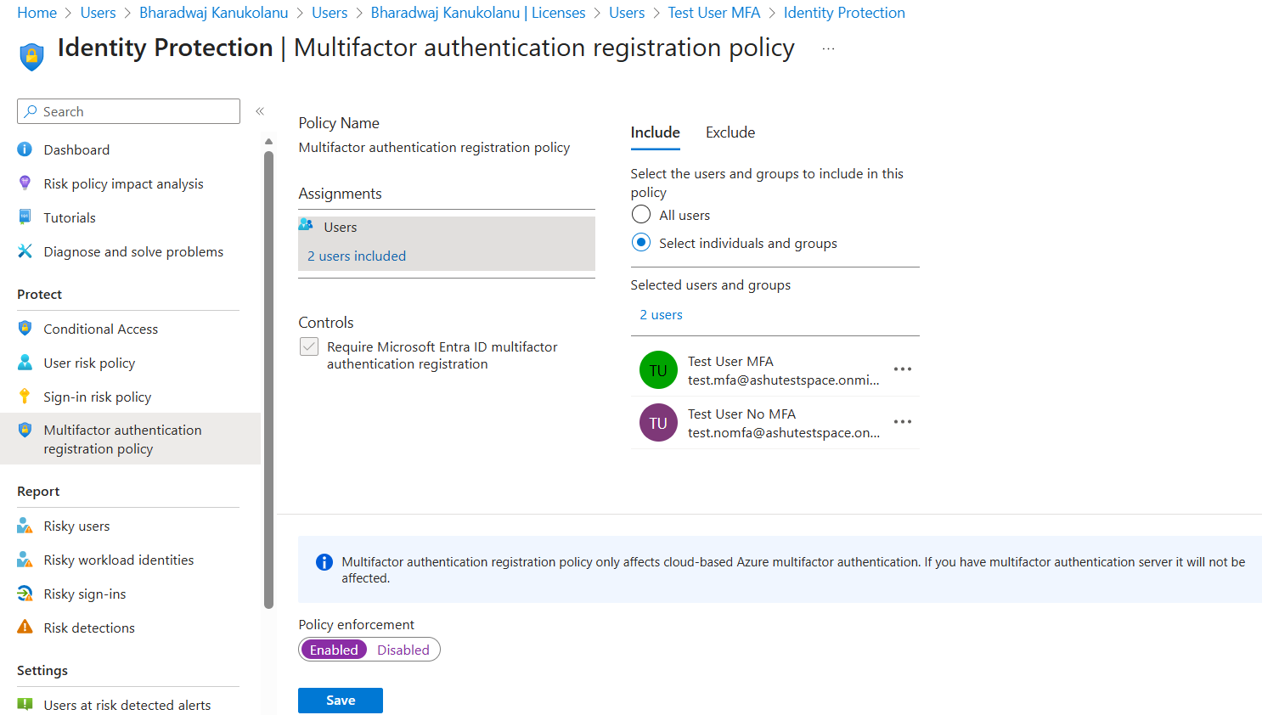
- Actionable Step: Now, sign out of your admin account and sign in as one of the new test users (e.g., test.mfa@yourdomain.com). The user will be forced to change their temporary password and then immediately be prompted to register their MFA method (e.g., Authenticator app). Complete this process for both users.
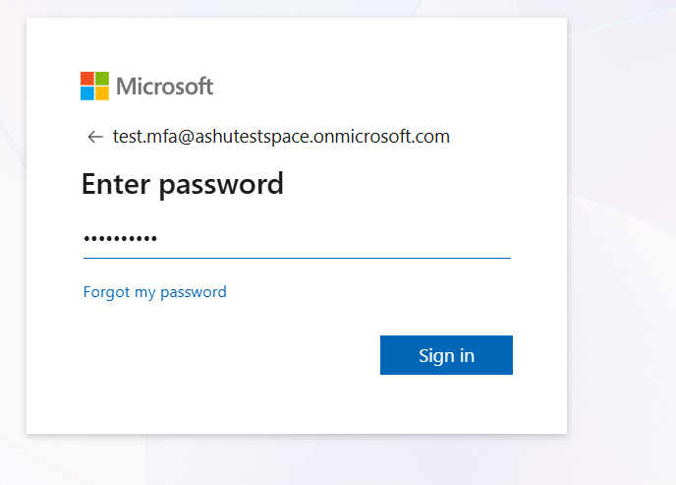
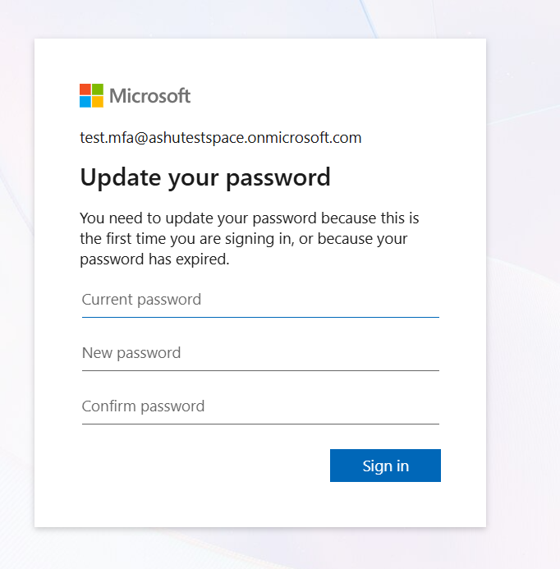
New password: Help12you$
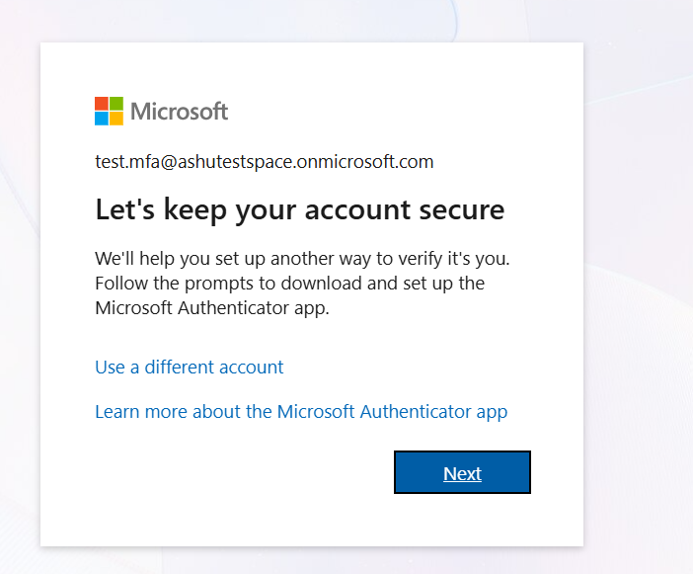
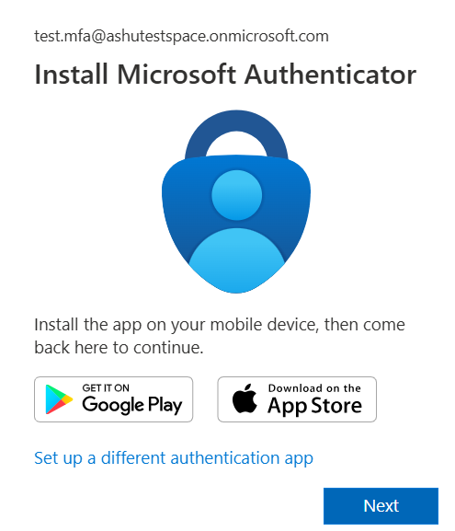
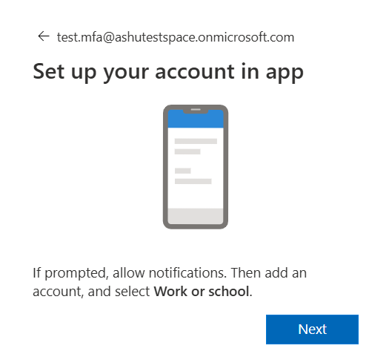
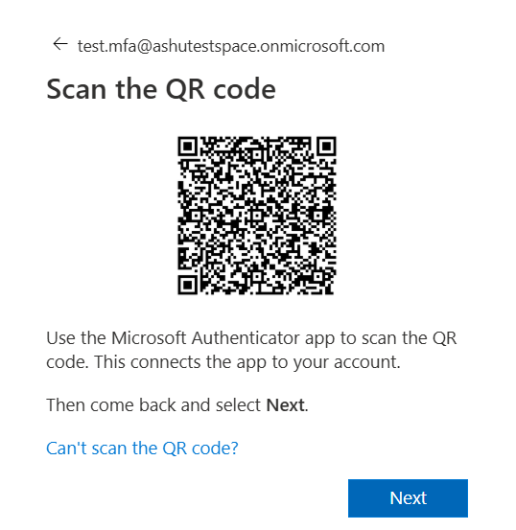
When I scan above QR code using authenticator app on the device, the test.mfa account got added to authenticator app.
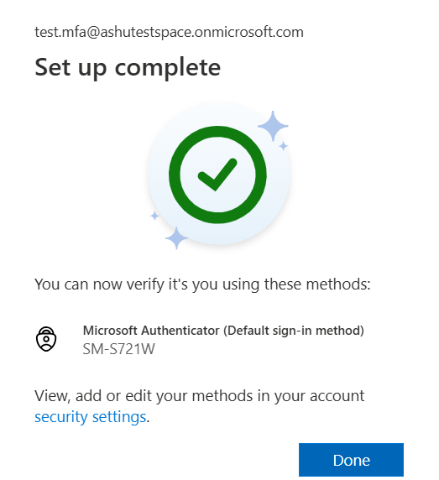
User 1 is successfully able to login to entra
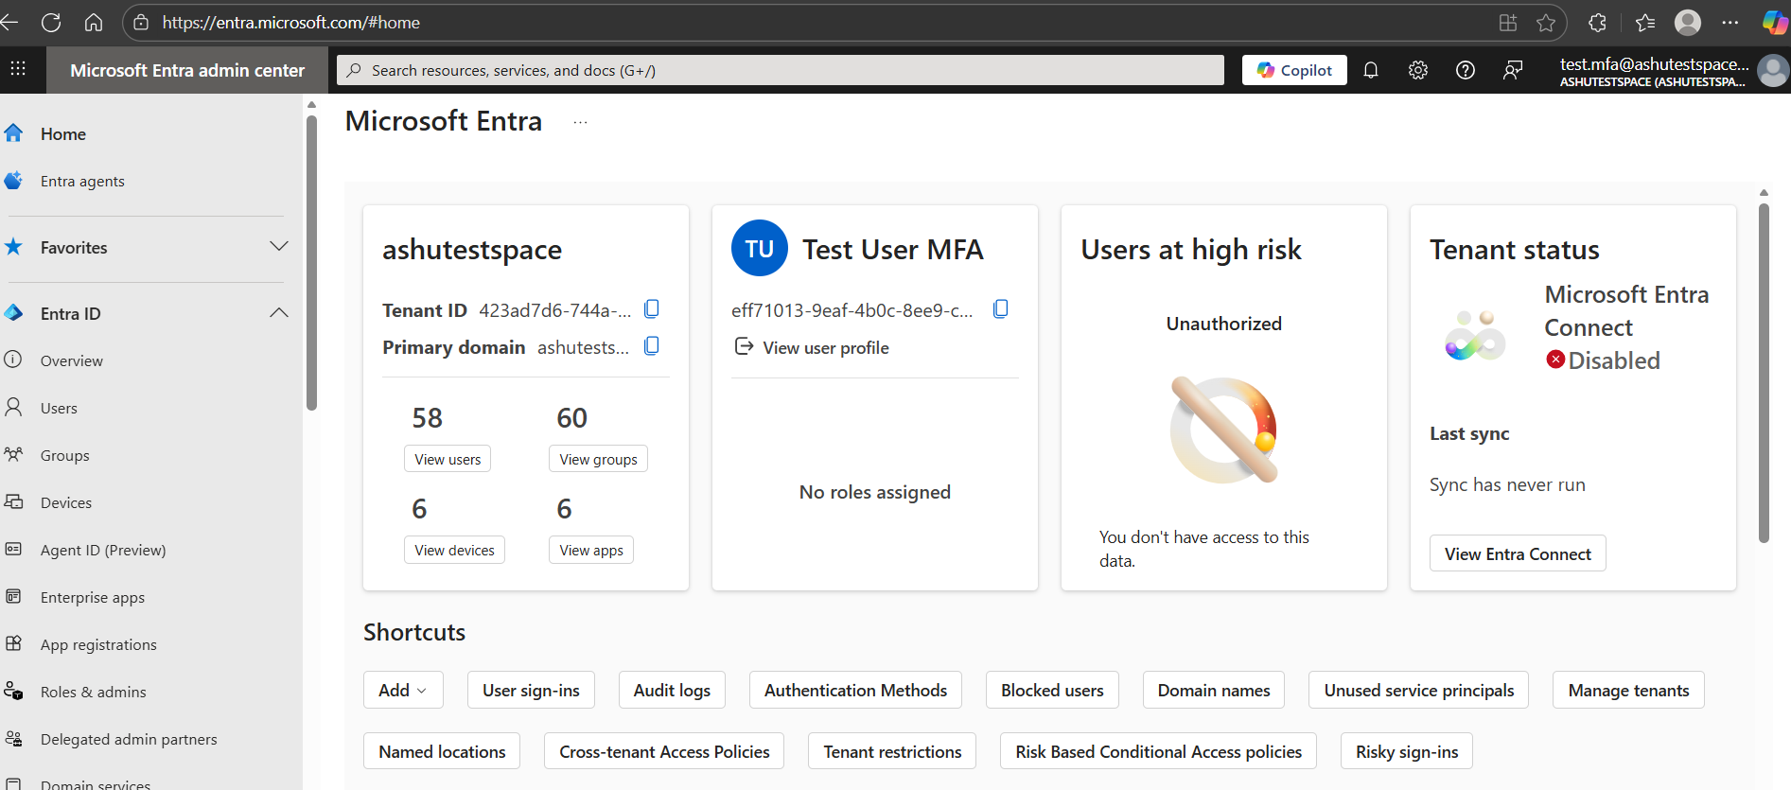
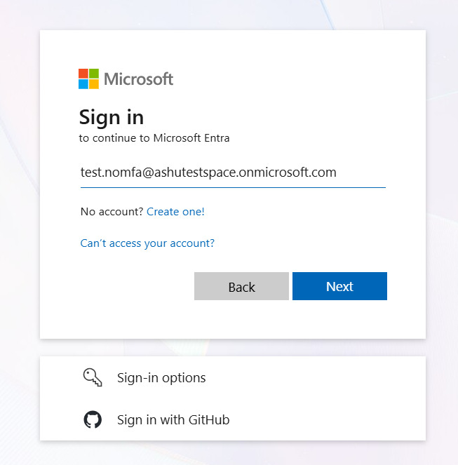
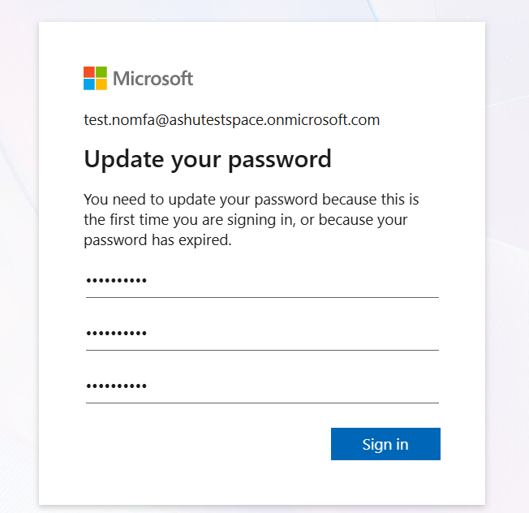
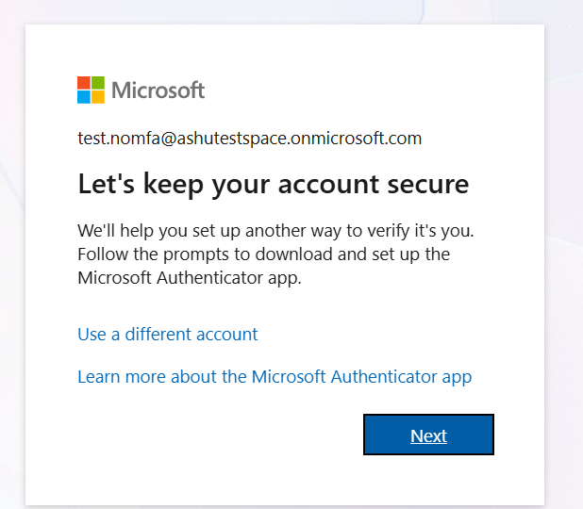
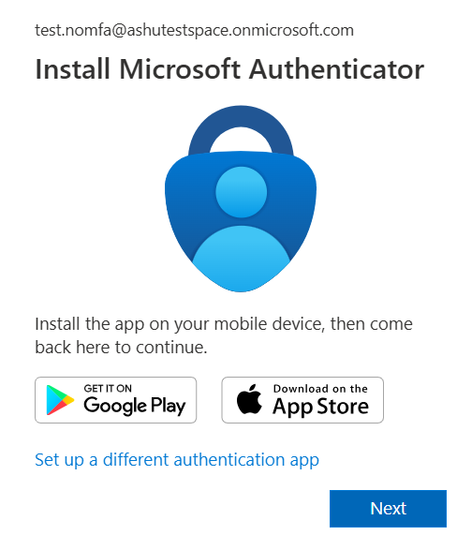
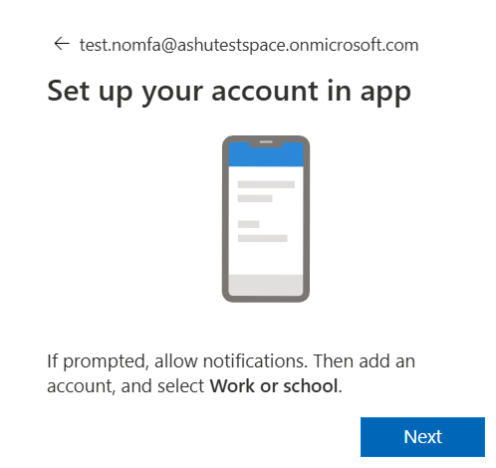
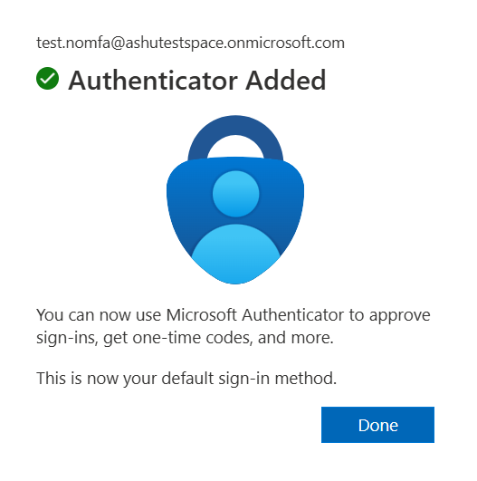
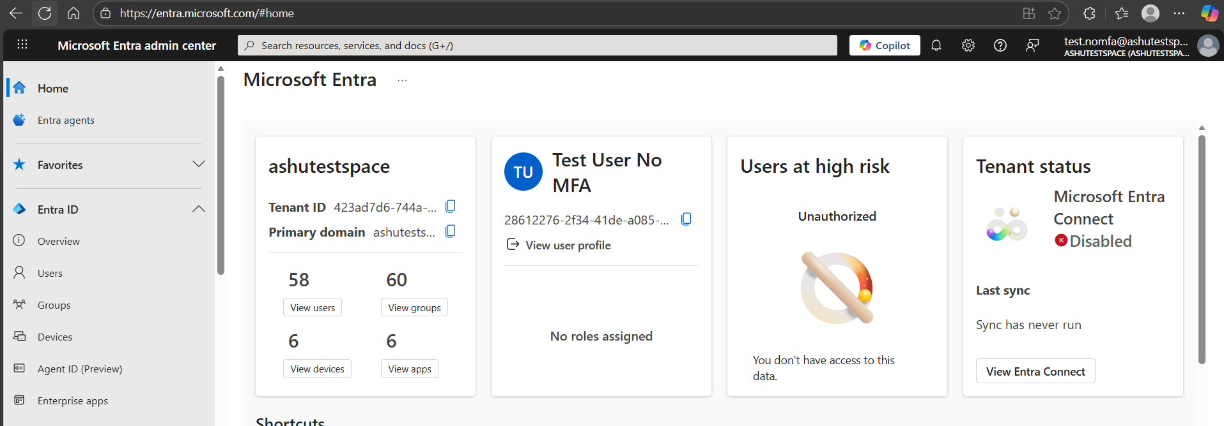
User 2 is successfully able to login to entra, new password Help13you$

Step 1: Navigate to Conditional Access
- Go to the Microsoft Entra admin center.
- In the left navigation menu, go to Protection > Conditional Access.
- Click + New policy.
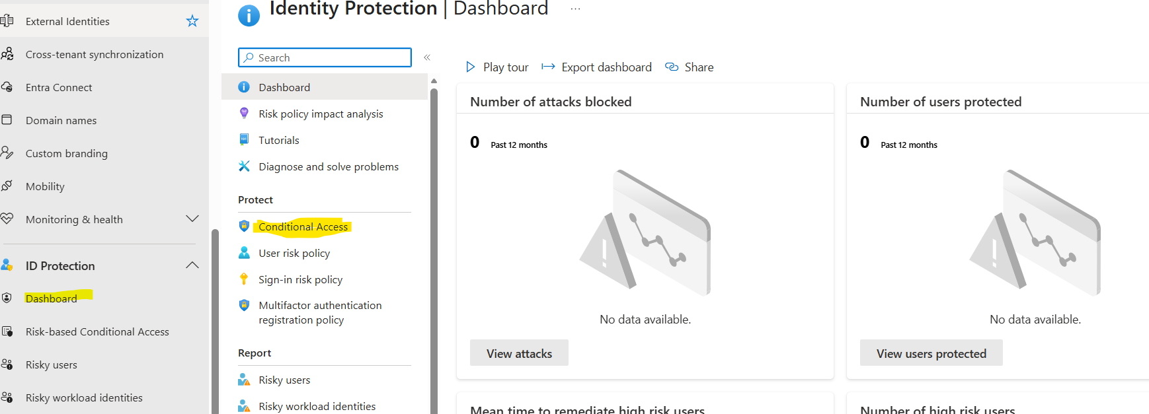
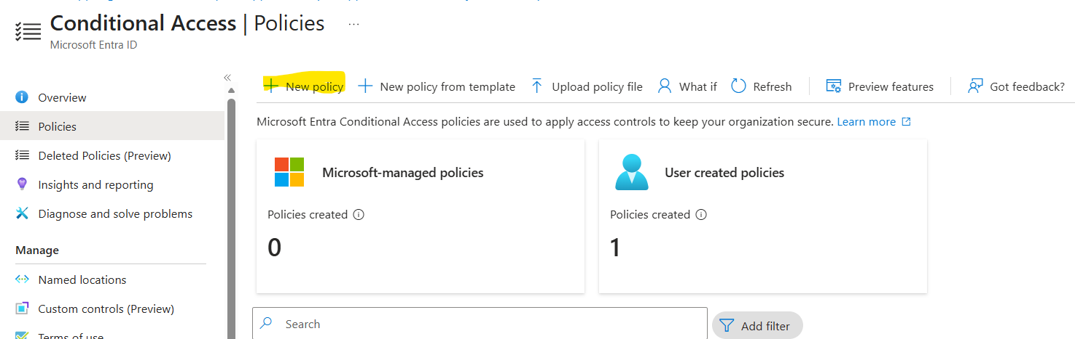

Step 2: Name the Policy and Configure Users
- Name: Give the policy a descriptive name.
  - Suggestion: CA01 - Require MFA for External Access to Sensitive App
- Users: Under Assignments, click on Users or workload identities.
  - Select 0 Users and groups selected.
  - Choose Select users and groups.
  - For a true test, select Include > All users (or the specific test user group).
  - Exclude: Crucially, exclude your Global Administrator account or another break-glass account. This prevents accidental lockout.
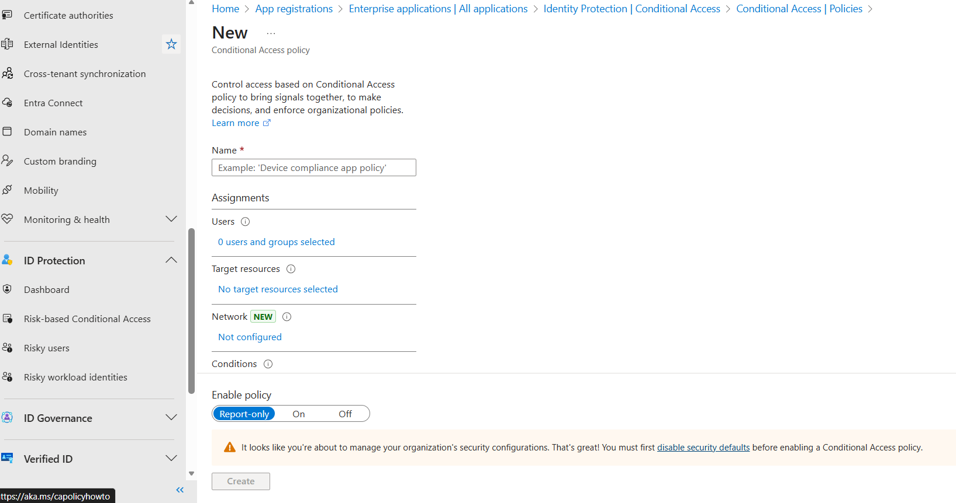
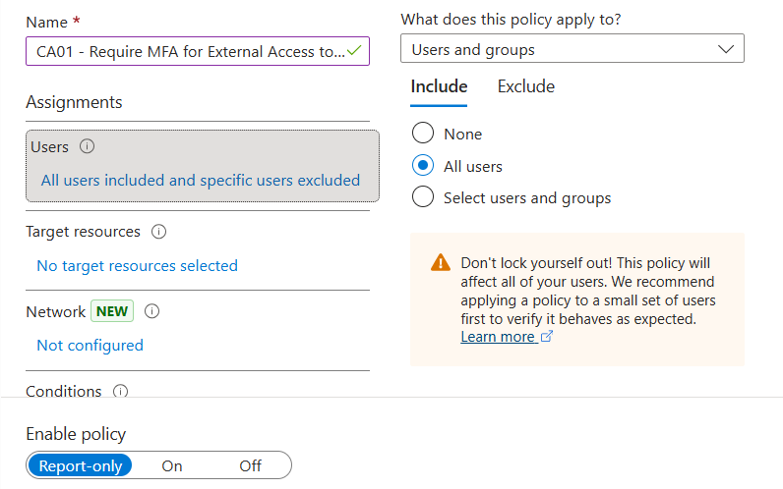
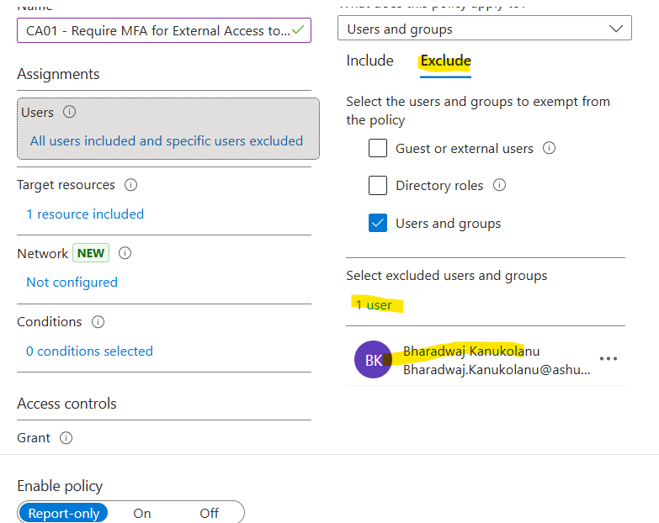

Step 3: Configure Target Resources (Cloud Apps)
- Target Resources: Under Assignments, click on Cloud apps or actions.
- Select 0 Cloud apps selected.
- Choose Select apps.
- Select your designated sensitive application (e.g., SharePoint Online, or a specific Enterprise application you registered for the lab).
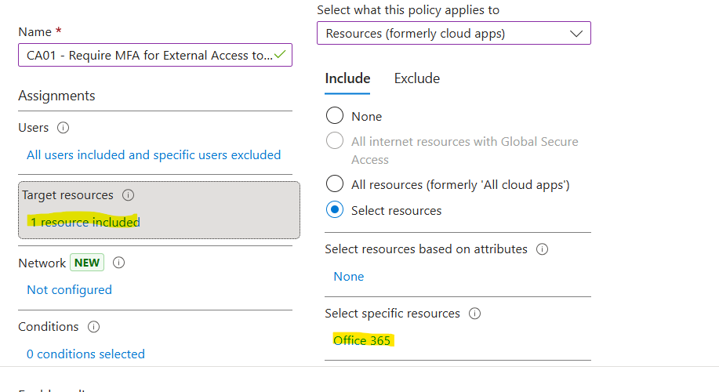

Step 4: Configure Conditions (Location)
Step 4: Test and Validate the Conditional Access Policy
This step validates that the policy works as intended by testing access from both your trusted (home) network and an untrusted (external) network.
4A. Prepare Your "Trusted" Location (Your Home IP)
Your home public IP address will be treated as the "trusted corporate network" for testing purposes.
- Find Your Public IP:
  - On your home computer, search for "What is my IP address" on Google.
  - Note the IPv4 address (e.g., 172.21.10.150).
- Create the Named Location in Microsoft Entra ID:
  - Sign in to the Microsoft Entra admin center.
  - Navigate to Protection > Conditional Access > Named locations.
  - Click + IP ranges location.
  - Name: Home Trusted Network
  - IP ranges: Enter your public IP address using CIDR notation (e.g., 172.21.10.150/32). Use /32 to specify a single host address.
  - Check the box: Mark as trusted location.
  - Click Create.
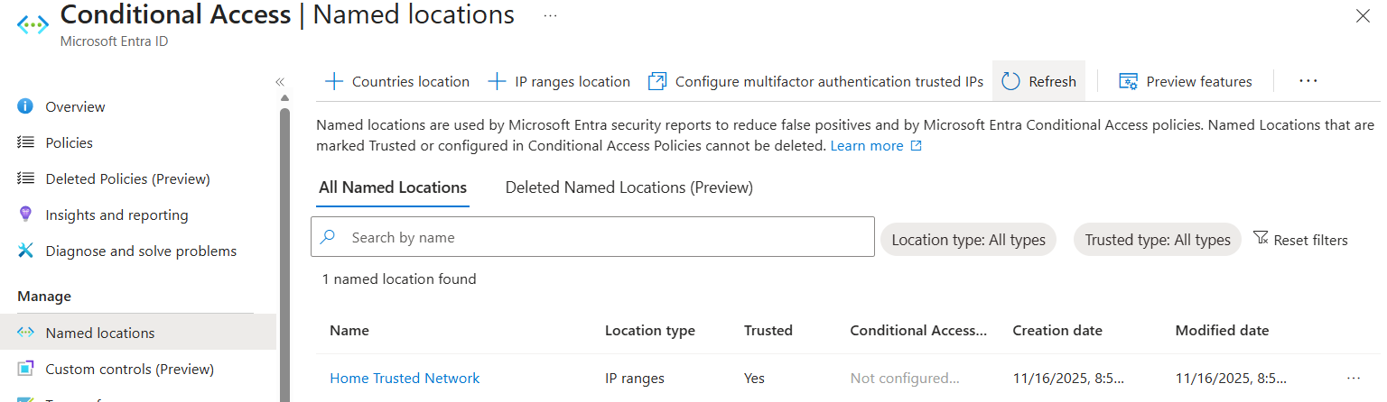
- Configure Policy Exclusion:
  - Go back to your Conditional Access policy (e.g., CA01 - Require MFA for External Access to Office 365).
  - Go to Conditions > Locations.
  - Change the setting from "Any location" to Selected locations.
  - Exclude the new Home Trusted Network location you just created.
  - Save the policy.
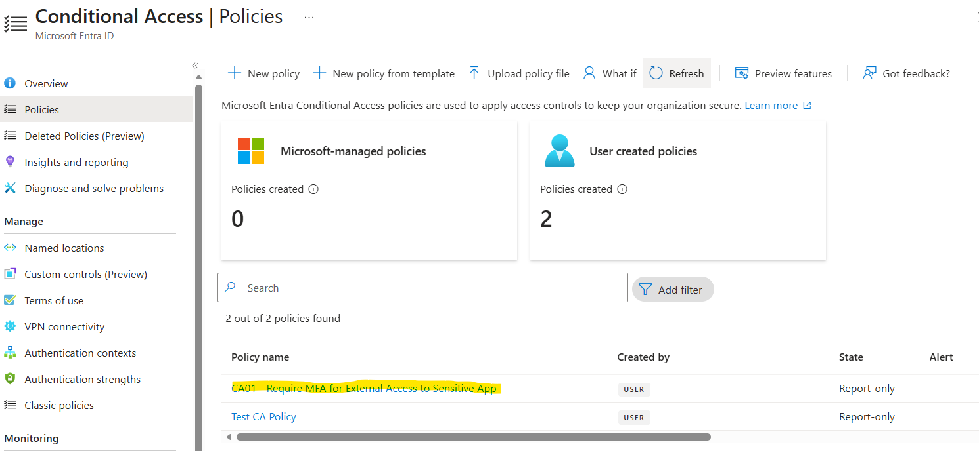
4B. Test Scenario 1: Inside the Network (Access Should Be Granted Without MFA)
This validates the exclusion. When accessing from your "trusted" IP, the policy should not apply.
- Ensure Connection: Make sure your computer is connected to your regular home Wi-Fi/Ethernet.
- Test Login: Open a clean private/incognito browser window.
- Sign in as your test user (not your admin account) to the sensitive application (e.g., https://outlook.office.com).
- Expected Result: Access should be granted using just the username and password (after the initial password change/MFA registration process). The user should NOT be prompted for MFA.

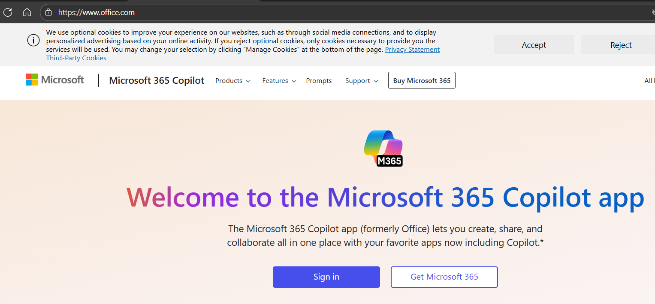
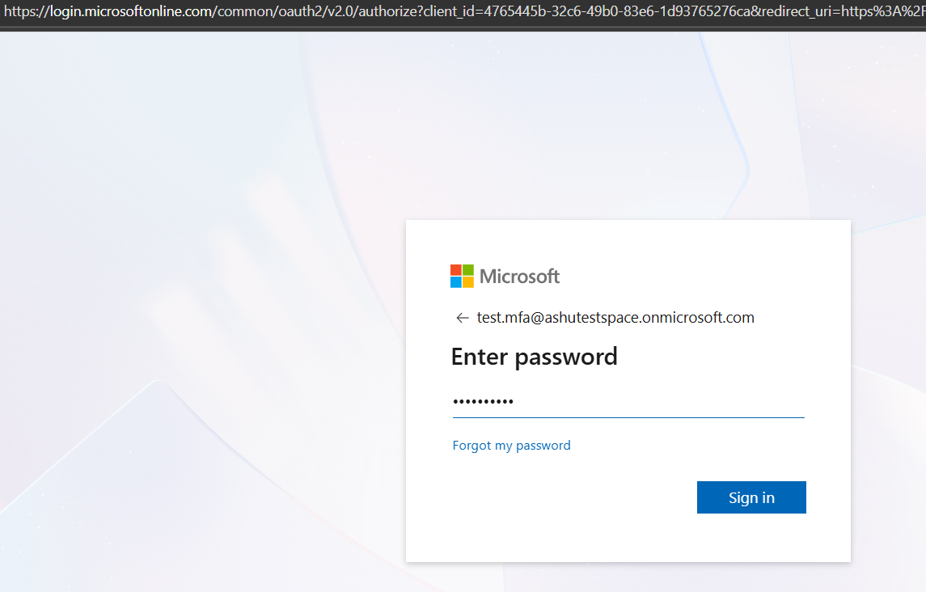
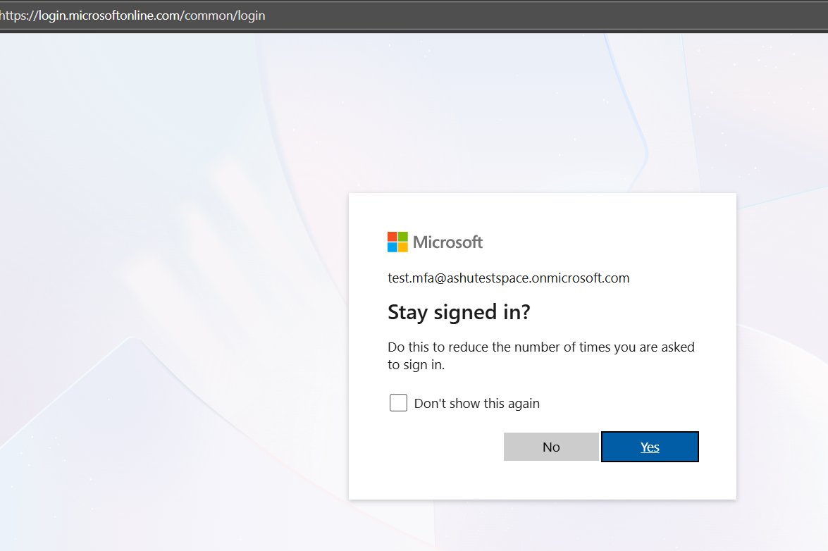
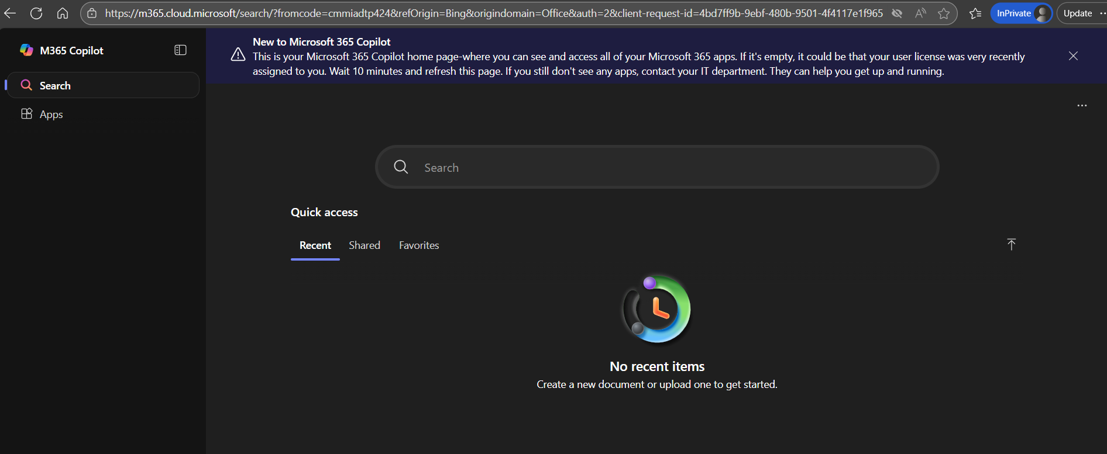
4C. Test Scenario 2: Outside the Network (MFA Must Be Prompted)
This validates the inclusion. When accessing from any other IP, the policy should apply and require MFA.
- Change Your Public IP: Switch your computer's internet connection to a different source, such as:
  - Use a Mobile Hotspot (Easiest method).
  - Connect to a VPN that routes your traffic through a different location.
- Test Login: Open a new clean private/incognito browser window.
- Sign in as your test user to the sensitive application.
- Expected Result: The user should be immediately prompted to perform Multi-Factor Authentication (e.g., approve a notification or enter a code). Access should only be granted after successfully completing MFA.

Note: Remember that network changes (like disconnecting from Wi-Fi and connecting to a hotspot) can sometimes take a minute or two to fully register on the client side. If your first test fails, wait a minute, close the browser, and try again.
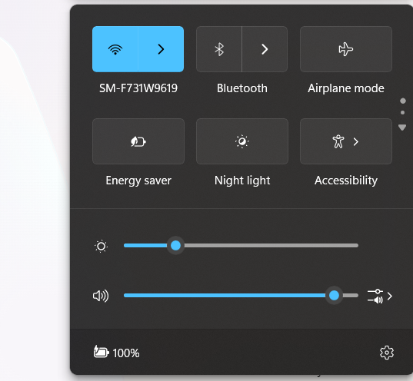
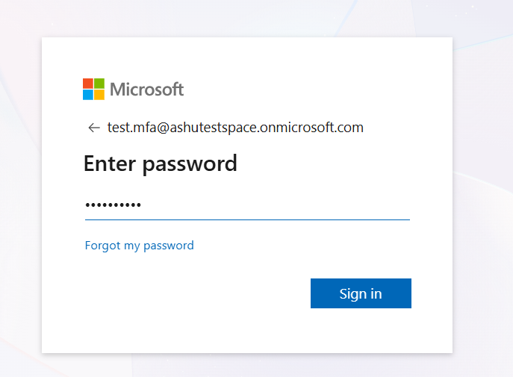
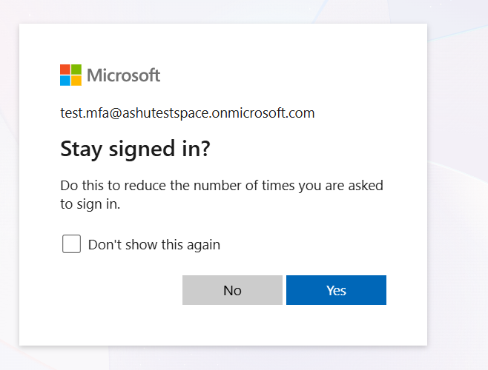
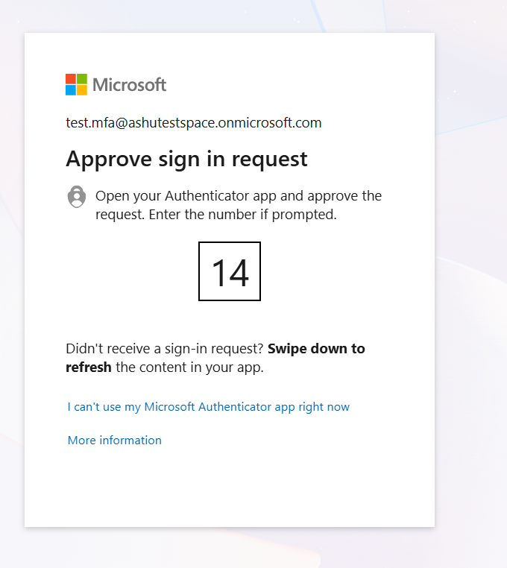
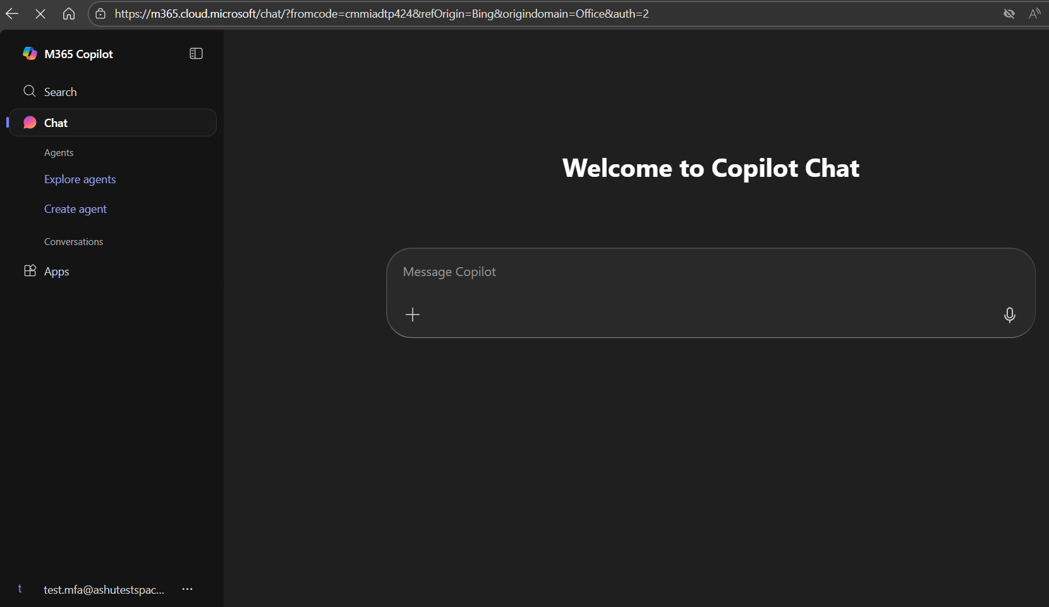

Step 5: Configure Access Controls (Grant)
- Grant: Under Access controls, click on Grant.
- Select the radio button Grant access.
- Check the box for Require multifactor authentication.
- Click Select.

Step 6: Enable and Test the Policy
- Enable Policy: At the bottom, change Enable policy from Off to Report-only.
  - Best Practice: Always start with Report-only mode to monitor the impact without enforcing it. Review the Conditional Access Insights and Reporting workbook to see which users and applications would be affected.
- Finalize: After testing in Report-only mode (checking the audit logs), change the policy to On.
- Test:
  - Have your test user log in to the sensitive application from inside the network location (if excluded). Access should be granted without prompting for MFA (if no other CA policy requires it).
  - Have your test user log in to the sensitive application from outside the network (e.g., using a phone hotspot or a VPN that places you outside the excluded IP range). The user should be immediately prompted for MFA.

Some key takeaways
- When a conditional access policy is setup and left in report only mode, then security defaults continue to apply.
- If a conditional access policy is in report only mode it does not enforce anything, it should be set to on mode in order for it to start enforcing conditions or rules.
- Security defaults are the baseline protections Microsoft enables by default, MFA for all users, blocking legacy auth etc.
Security defaults are on if you haven’t created or enabled conditional access policies. They cannot be customized its either on or off.

Scenario 1 – when no session settings in place.
    - User 1 OR 2 logs into office 365 app from home Wi-Fi in incognito mode browser, no MFA triggers.
Because locations – includes – any network or location.
excludes – selected networks and locations which is home trusted network (contains public IP address, which is the address assigned by your Internet Service Provider (ISP) to your entire home network which has been excluded that is why MFA has not been triggered.

    - User 1 OR 2 logs into office 365 app when laptop is connected to internet via mobile hotspot, No MFA triggers because the system reused the MFA Claim from the first login in the same session/environment.

Scenario 2 – when session settings in place that is sign in frequency set to every time.
    - User 1 and User 2 logs, one after the other into office 365 app from home Wi-Fi in incognito mode browser, MFA triggers.
    - User 1 and User 2 logs, one after the other into office 365 app when laptop is connected to internet via mobile hotspot, MFA triggers

